1. Print Linked List

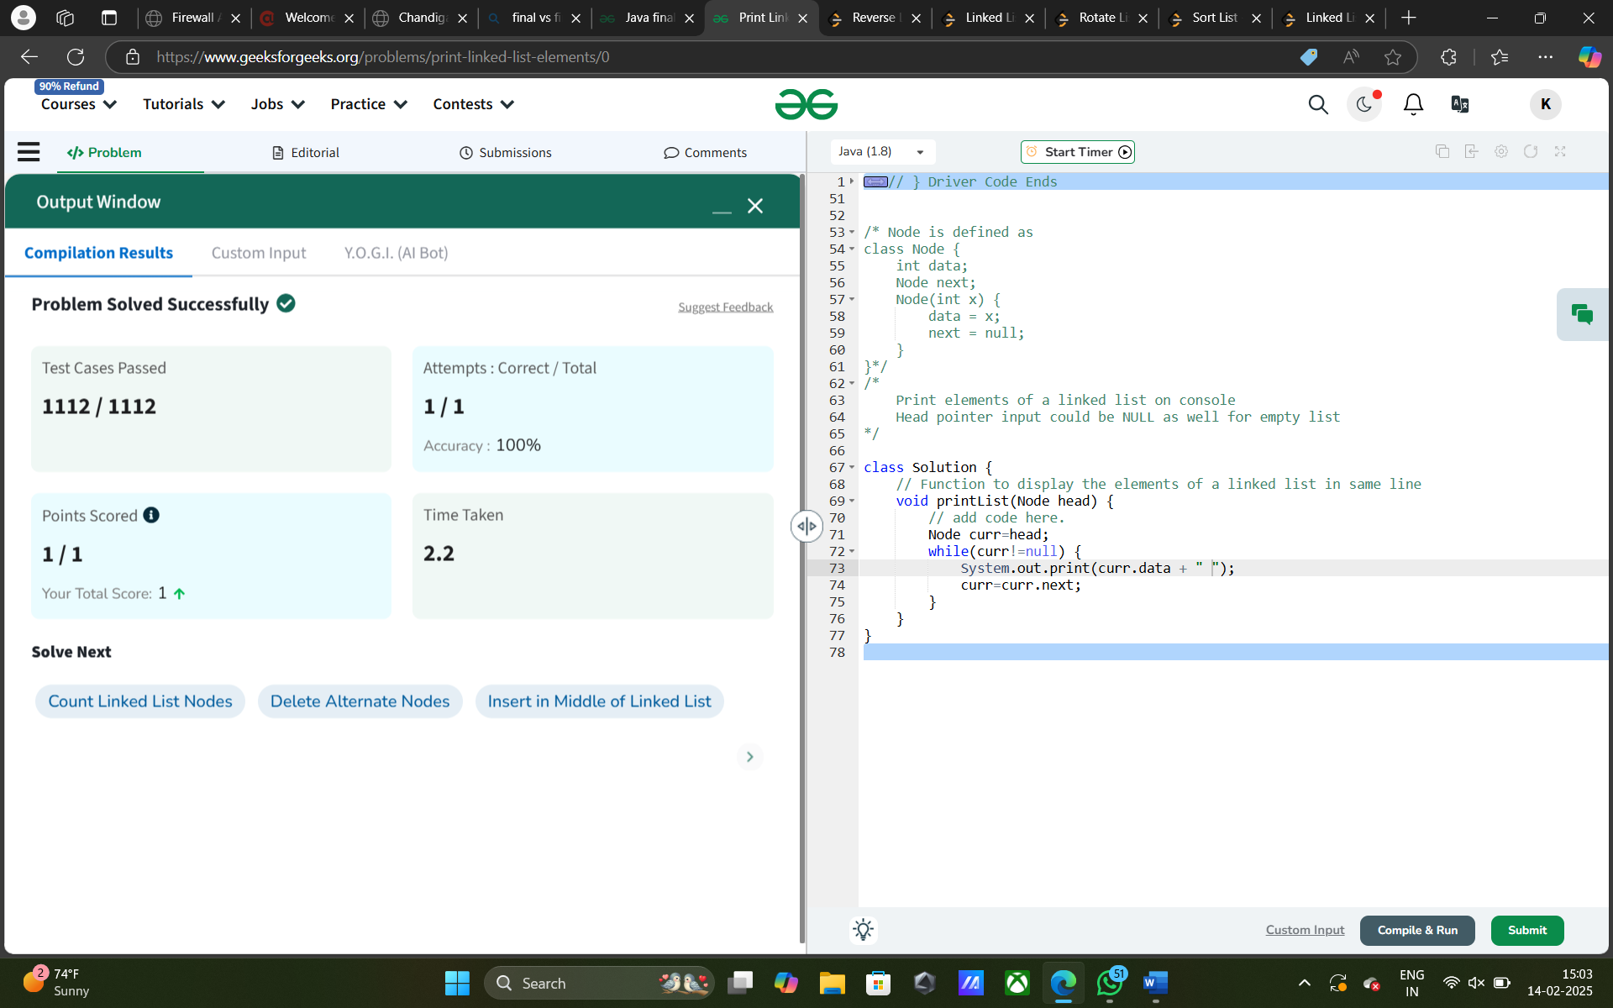

[**83. Remove Duplicates from Sorted List**](https://leetcode.com/problems/remove-duplicates-from-sorted-list/)

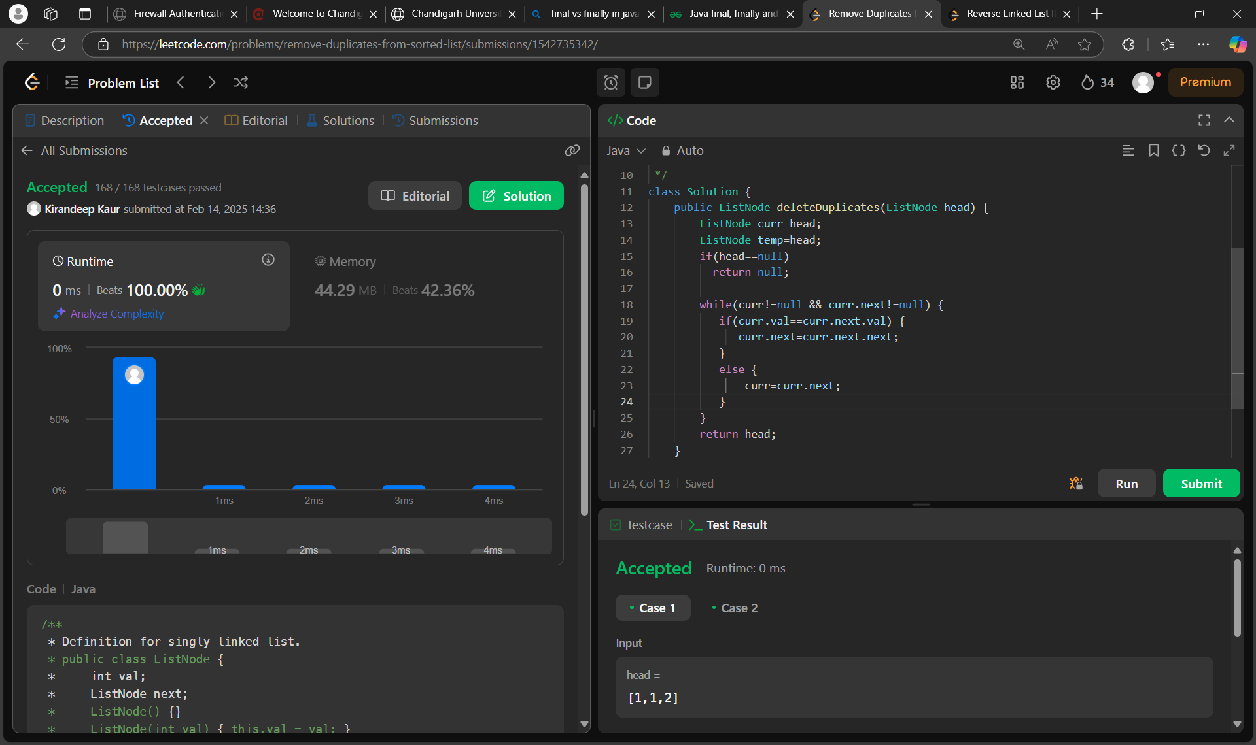

[**206. Reverse Linked List**](https://leetcode.com/problems/reverse-linked-list/)

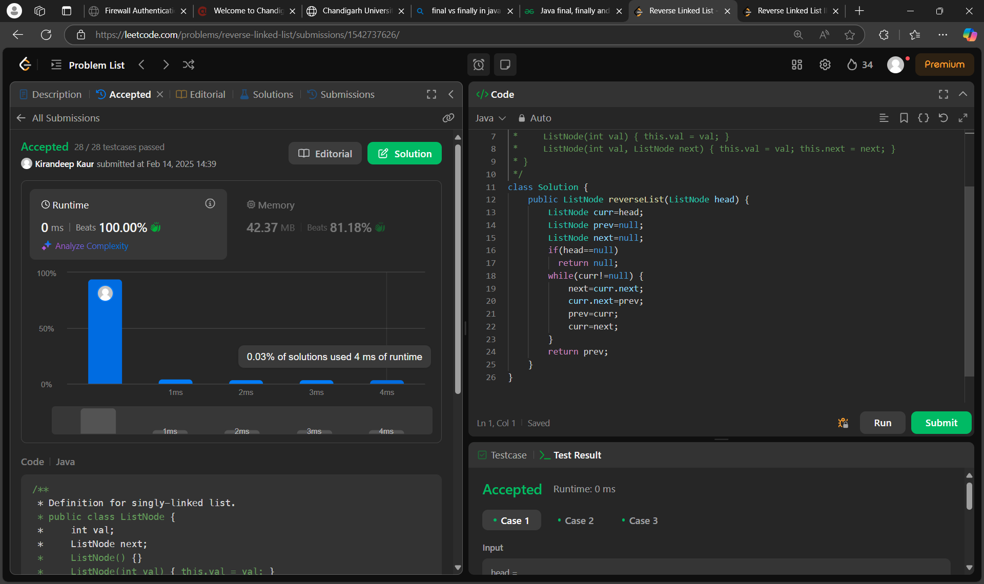

[**2095. Delete the Middle Node of a Linked List**](https://leetcode.com/problems/delete-the-middle-node-of-a-linked-list/)

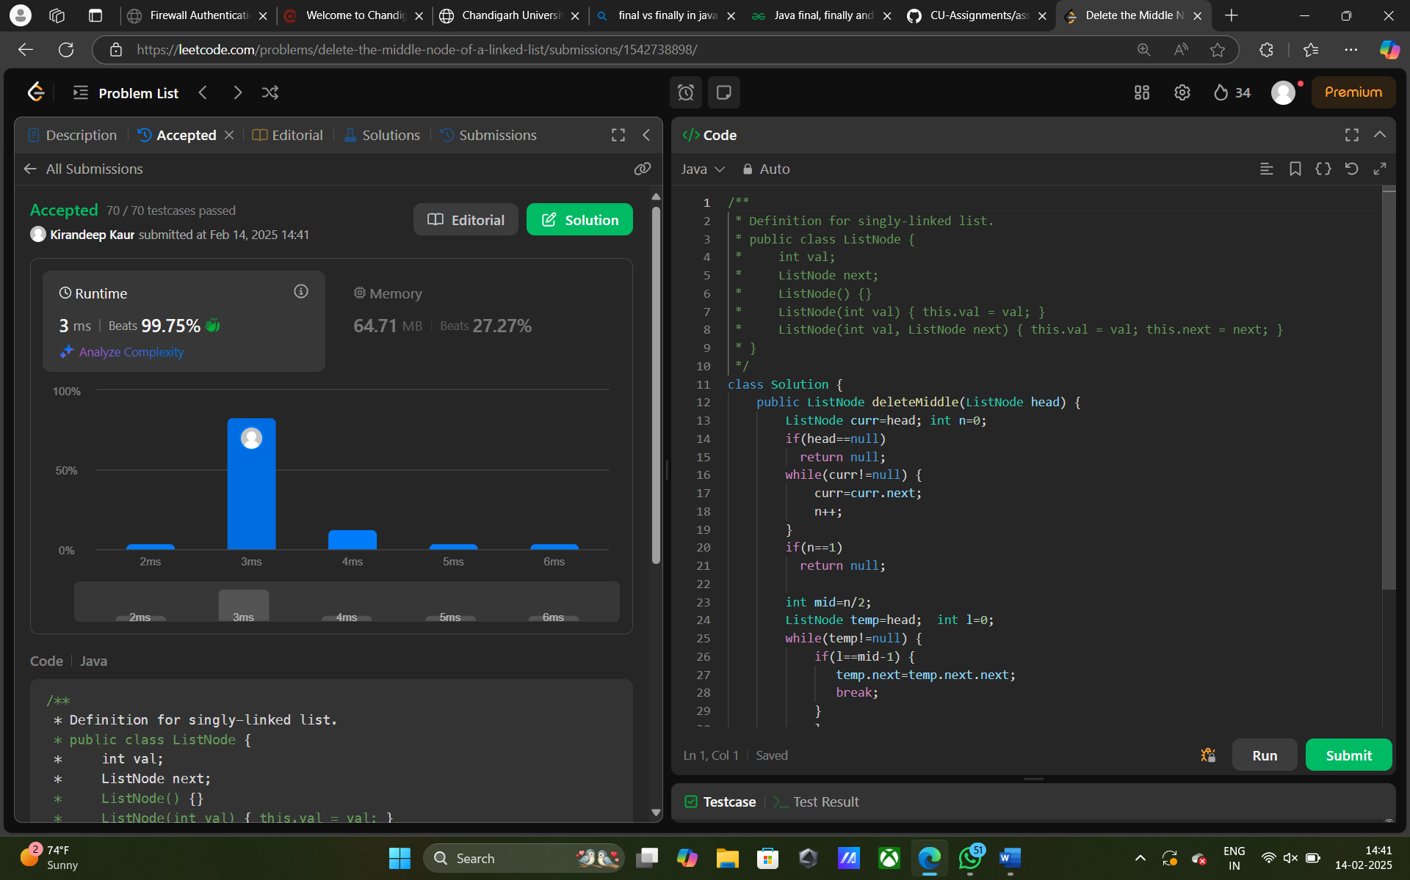

[**21. Merge Two Sorted Lists**](https://leetcode.com/problems/merge-two-sorted-lists/)

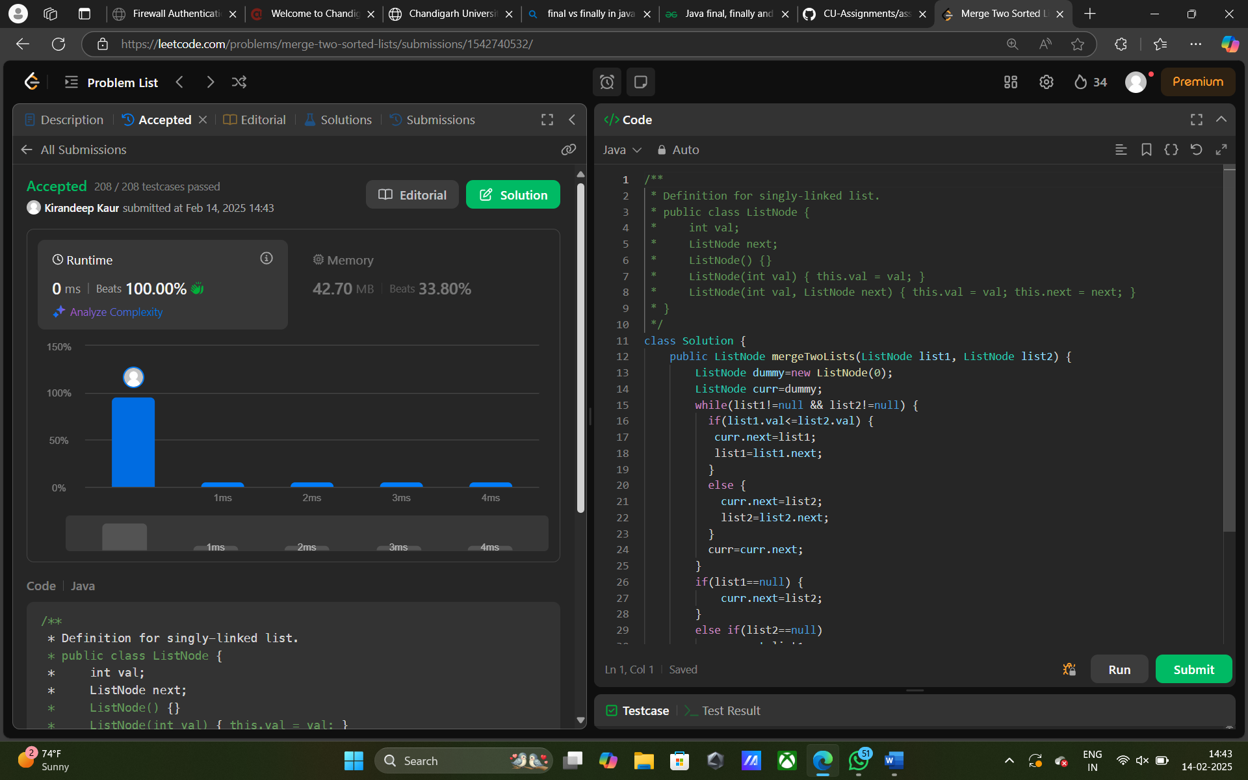

[**82. Remove Duplicates from Sorted List II**](https://leetcode.com/problems/remove-duplicates-from-sorted-list-ii/)

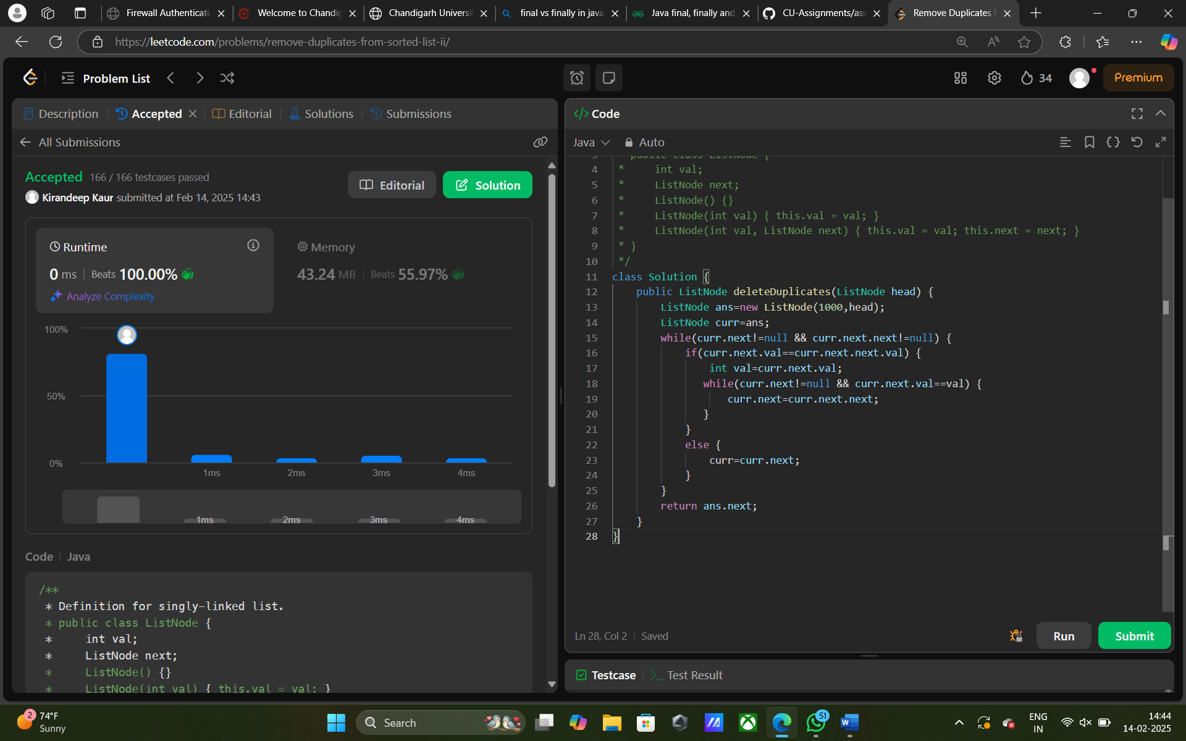

[**141. Linked List Cycle**](https://leetcode.com/problems/linked-list-cycle/)

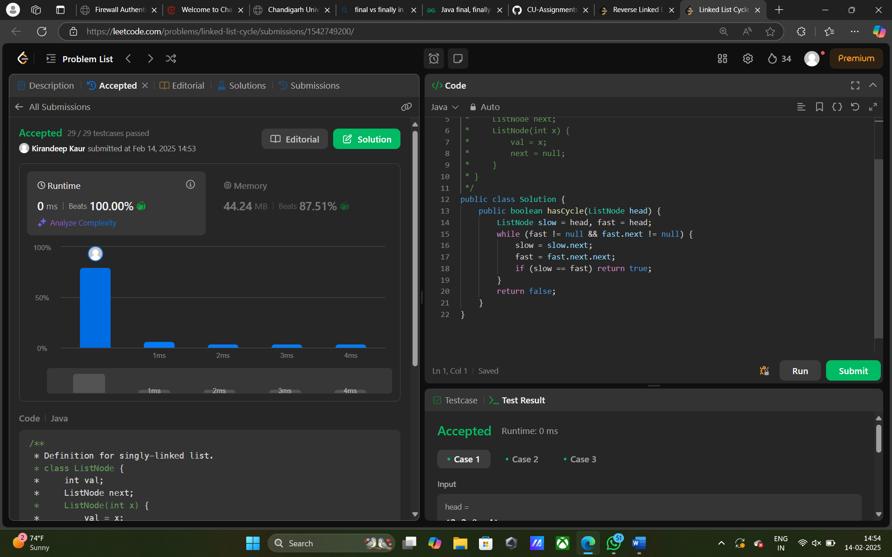

[**92. Reverse Linked List II**](https://leetcode.com/problems/reverse-linked-list-ii/)

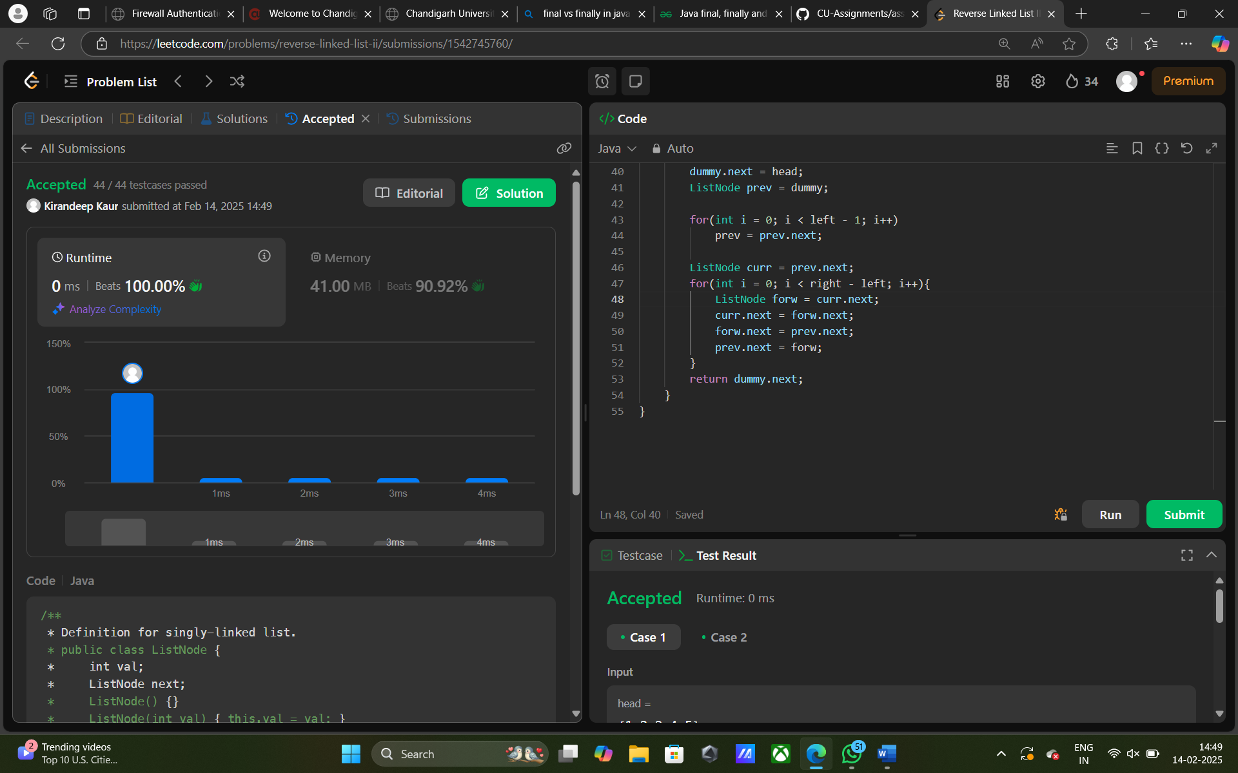

[**61. Rotate List**](https://leetcode.com/problems/rotate-list/)

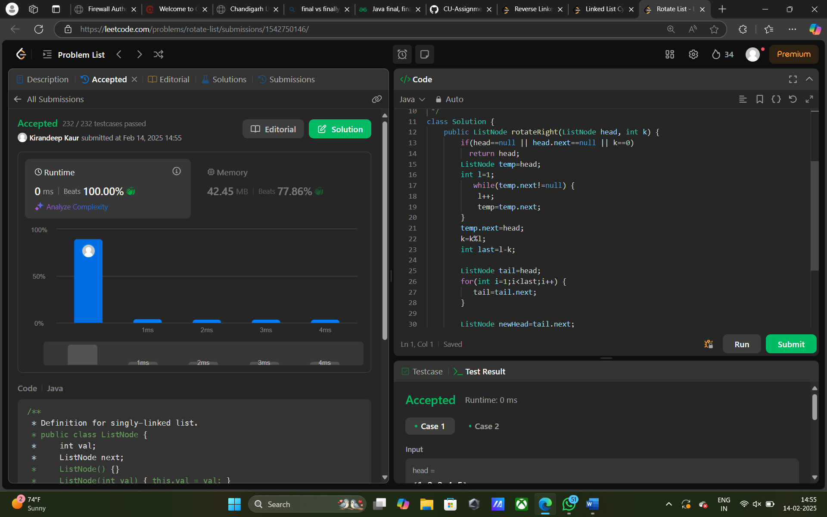

[**148. Sort List**](https://leetcode.com/problems/sort-list/)

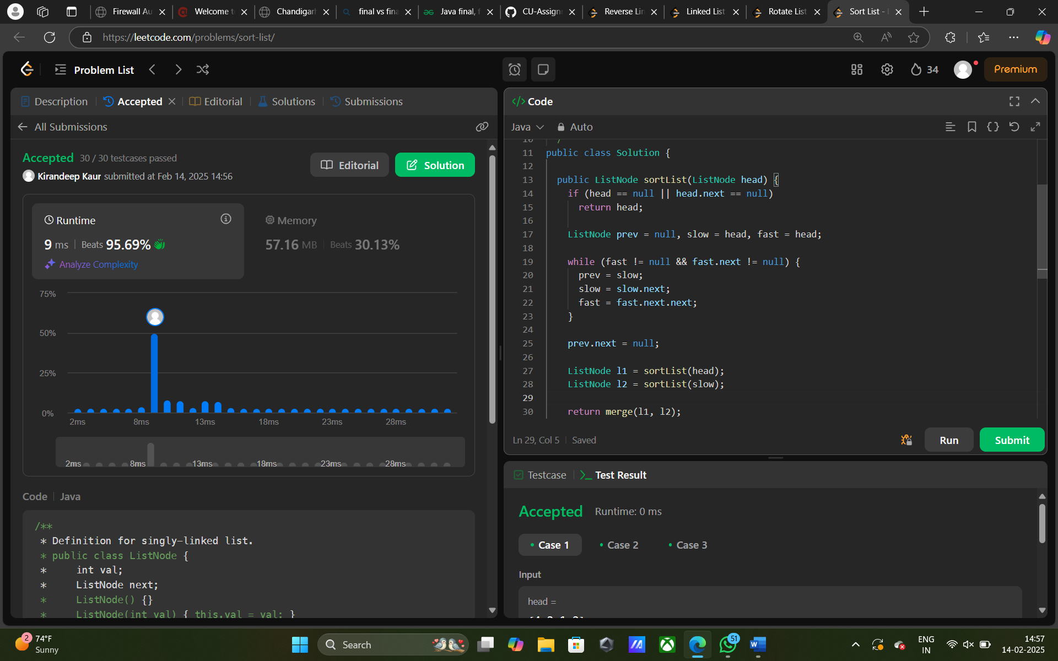

[**142. Linked List Cycle II**](https://leetcode.com/problems/linked-list-cycle-ii/)

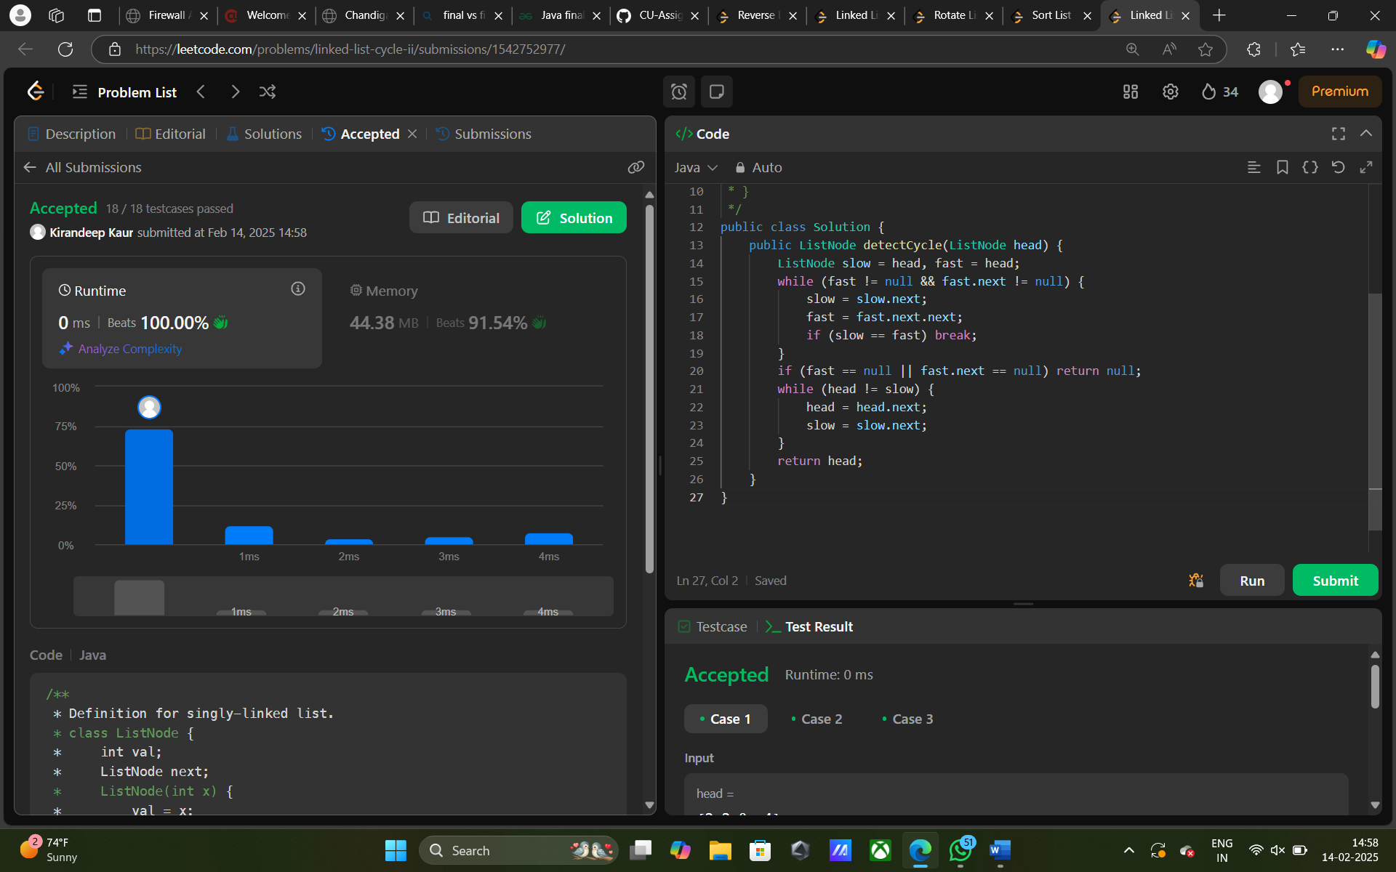

Kirandeep Kaur (22BCS13511)